Name: Sanika Botre PRN: 25070122063
Batch: 2025-29 Branch: CSE A-2
Subject: Programming with Java

ASSIGNMENT No: 11

TITLE : Write a Java program to demonstrate the implementation of interfaces.

Problem Statement: Write a Java program to demonstrate the implementation of interfaces.

Learning Objectives: To implement interfaces for achieving abstraction and multiple inheritance of type.

Theory:

An interface specifies a set of abstract methods that implementing classes must define. It provides complete abstraction and supports multiple inheritance of type. Interfaces improve modularity, loose coupling, and software flexibility. They allow different classes to implement common behavior while maintaining independent implementations. Interfaces are widely used in enterprise application development.

Exercise:

1. Create an interface Printable and implement it in Student and Employee classes.

Code:-

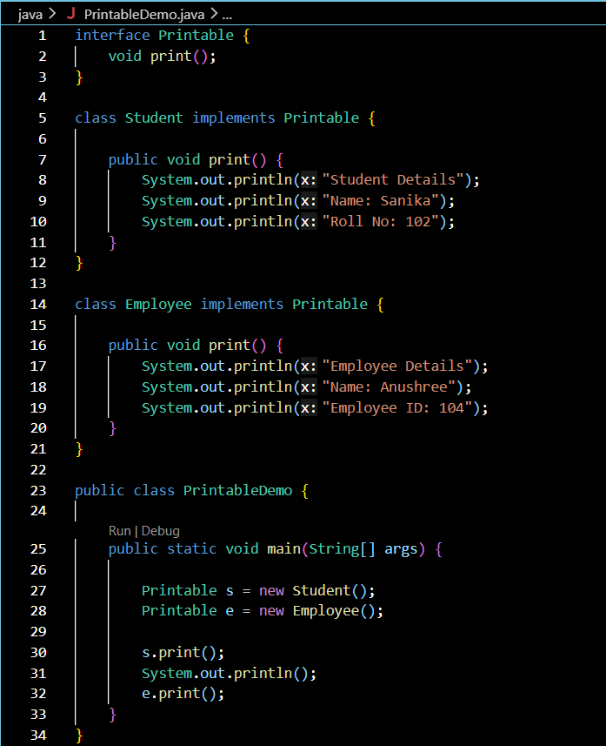

Output:-

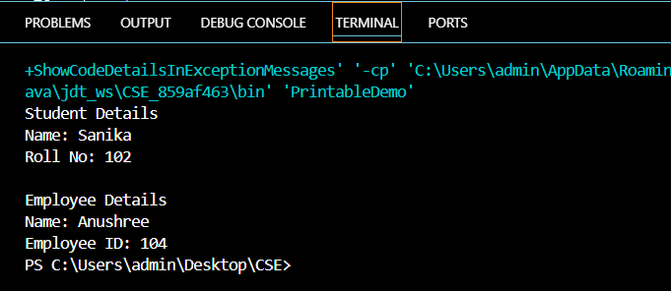

2. Create an interface Switchable with a method turnOn(). Implement the interface in Light and Fan classes to display the device status.

Code:-

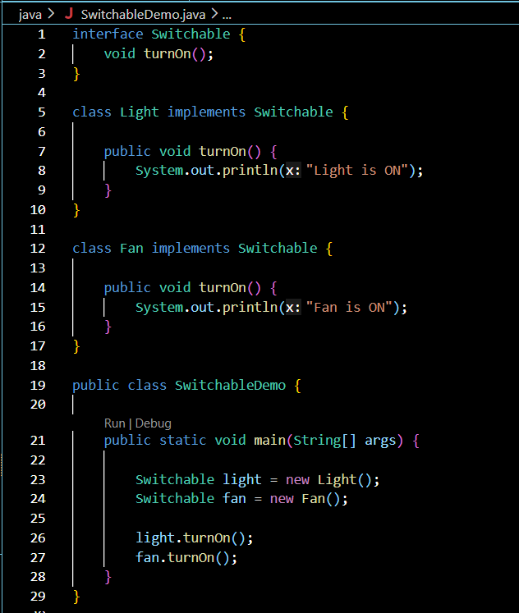

Output:-

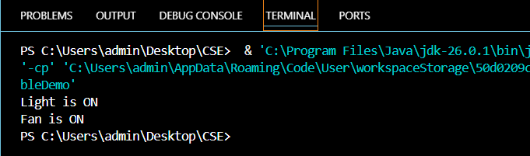

Conclusion:

This assignment successfully demonstrated the implementation of interfaces in Java. The Printable and Switchable interfaces were implemented by different classes to perform specific tasks, showing how interfaces achieve abstraction and support polymorphism. The programs executed successfully and produced the expected output. Overall, this assignment enhanced the understanding of interfaces and their importance in developing flexible, reusable, and object-oriented Java applications.

